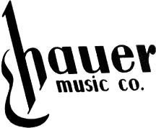
March Musical Madness Sale

Super Clearance on All in Stock Items - including rental returns, trade-ins, discontinued items, scratch-n-dent, nothing held back
er- Founder
Over 1000 items have been reduced to their absolute lowest prices

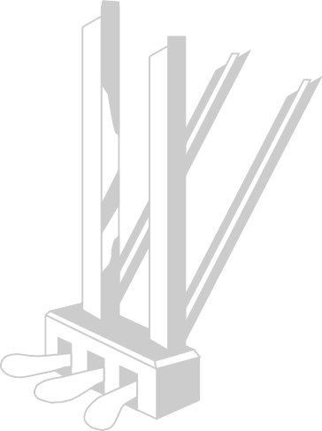
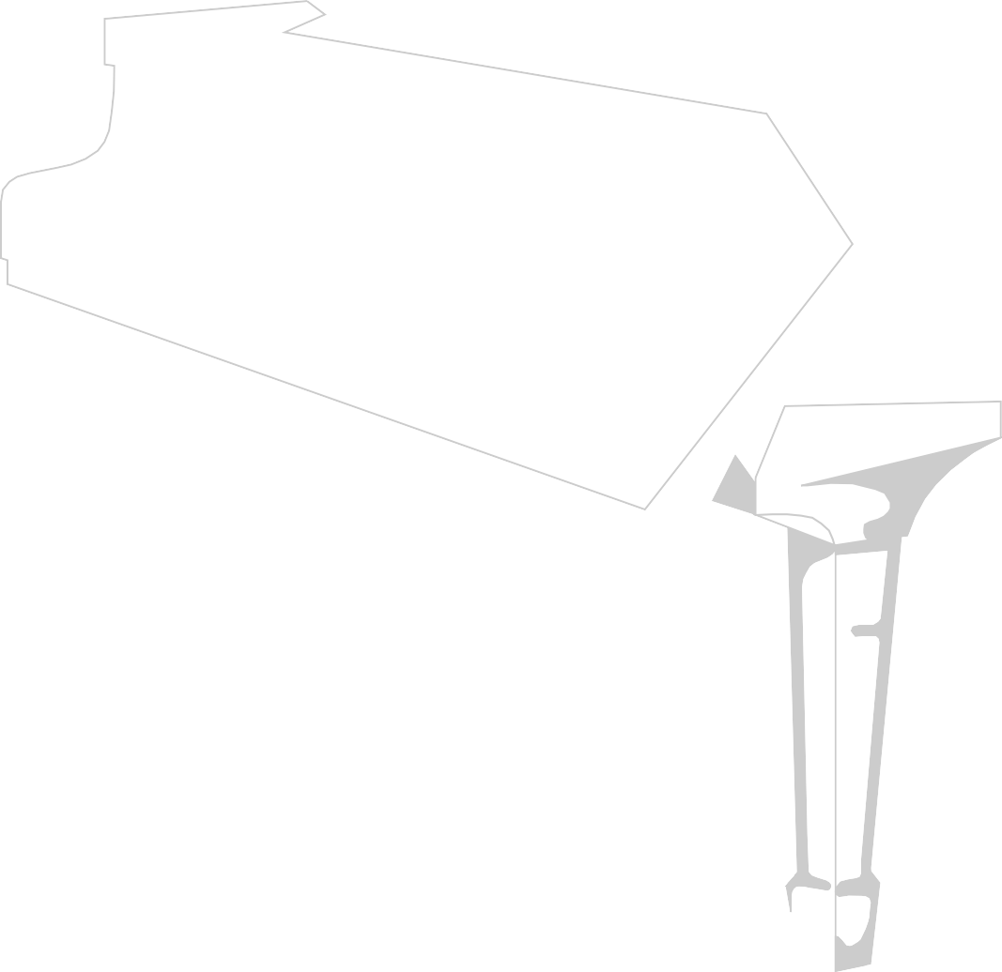
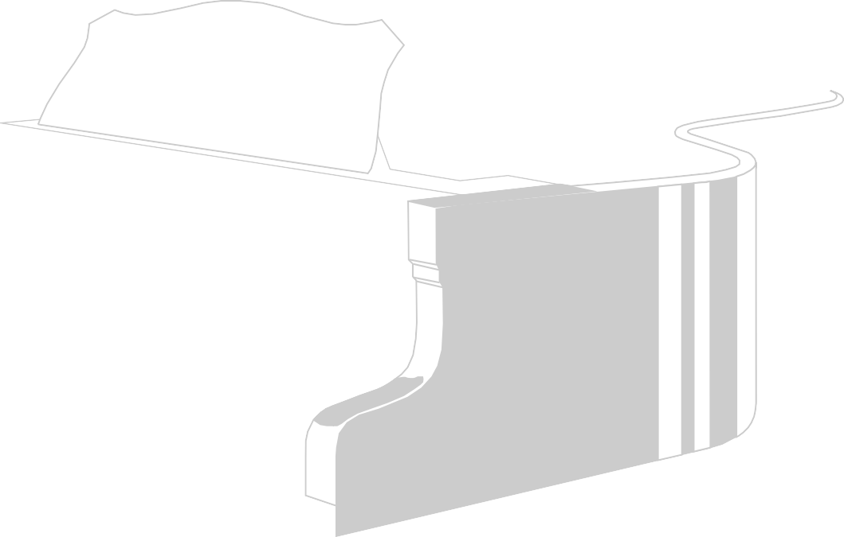
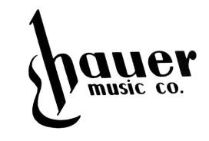
Guitars & Amplifiers
Gretsch G2622T Elec Guitar Was $780 Now $499
Fender ’65 Dlx Reverb Amp Was $2180 Now $1499 Fender ’65 Princeton Amp Was $1888 Now $1349 EVH 5150 6L6 Head Was $1812 Now $1199 Alvarez MF600M Guitar Was $1000 Now $659 Yamaha CPX1200II Guitar Was $2330 Now $1249
Fender CC-140SCE w/Case Was $575 Now $379
Gold Tone OB-3 Banjo Was $2300 Now $1699
Ibanez GSR200 Bas Was $329 Now $199 Yamaha TRBX605F Was $1152 Now $629 Ortega R55BFT Classica Was $330 Now $199 Fender Am. Pro II Stra Was $2272 Now $1649 Squier Paranormal Cyc Was $575 Now $399 Fender Am. Ultra Luxe Tele Was $3400 Now $2499 Ibanez AG95 Jazz Box Was $1000 Now $599 Fender Noventa Stra Was $1452 Now $949 F ender Super Reverb Am Was $2600 Now $1949 EVH 5150 Combo 40 Was $1250 Now $895 Fender CD60 w/ Dlx Ca Was $330 Now $199 Gretsch Double Jet Bigsby Was $ 940 Now $579
OVER 300 GUITARS IN STOCK!!!
GUITAR STRINGS - BUY 1 GET ONE FREE!!

Pianos & Keyboards
Mason & Hamlin 7' Grand Was $32000 Now $11500 Yamaha 76-Key Keyboard Was $539 Now $249 Yamaha P-143B “ Was $700 Now $499
Yamaha P-225B “ Was $1000 Now $699
Yamaha P-515B Digital Was $2000 Now $1399 Yamaha C1X Baby Grand Was $40000 Now $28999 Yamaha Disklavier Grand Was $25500Now $19999 Yamaha YDP-184 Clav. Was $2800 Now $2399
Yamaha CVP-805 Digital Was $9200 Now $7500
Yamaha EZ300AD Keyboard Was $400 Now $199

Selected Used Pianos -FREE FREE FREE- Hurry In!
-Dayton’s Only Authorized Yamaha Dealer-

Band Instruments
Yamaha YFL-200ADIIY Flut Was $1153 Now $ 692 Yamaha YFL-472HALY Flute Was $4270 Now $2499 Pearl PF200 Flute Was $ 998 Now $ 649 Pearl Elegante Flute Was $6153 Now $4000 Blessing BFL-1287 Flute Was $1095 Now $ 599 Yamaha YPC-32 Piccolo Was $2313 Now $1619 Yamaha YCL-200AD Clarinet Was $1198 Now $ 719 Yamaha YCL 650 Clarinet Was $3190 Now $2294 Blessing BCL-1287 Clarinet Was $1119 Now $ 650 Yamaha YCL-550AL Clarinet Was $2829 Now $1975
Yamaha YOB-441T Oboe Was $7168 Now $4778 Yamaha YAS-200 Alto Sax Was $2550 Now $1658 Used Selmer Alto Sax Was $9999 Now $4500 Yamaha YAS-82Z Alto Sax Was $6983 Now $4495 Yamaha YTS-82Z Tenor Sax Was $7937 Now $5900 Yamaha YTR-8335IIS Trpt Was $4594 Now $3198 Yamaha YTR-200AD Trpt Was $1577 Now $ 947
Antigua Vosi Trombone Was $1499 Now $899
Yamaha YSL-881G T-bone Was $4376 Now $2499
Yamaha YHR-570DAL F Horn Was $6900 Now $4830
Drums
Pearl Crystal Beat 4pc Shell Was $2896 Now $1740 Tama Imperialstar 5pc Set Was $1500 Now $899 Sonor Vintage Series 3pc Was $6349 Now $3809 Gretsch 4pc Catalina Club Was $1355 Now $949 Yamaha DTX432K Electronic Was $899 Now $599 Yamaha DTX6KX Set Was $1360 Now $999
Rogers Powertone 3pc Shell Was $4000 Now $2600
Yamaha Absolute Hybrid 4pc Was $6278 Now $3540 Ludwig Pocket Kit Jr Set Was $614 Now $399 Yamaha Recording Cust. 4pc Was $7476 Now $4220 Roland TD17KVX2 Electronic Was $2855 Now $1999 Yamaha Stage Cust. 5pc Was $1827 Now $1110 Roland TD02K Electronic Set Was $570 Now $399
Meinl Conga Set w/ stand Was $875 Now $529
100's of cymbals, drum bags, cymbal bags, thrones, and many more items all at the lowest prices. We Will Not Be Under Sold

Hurry, Many Items are One-of-a-Kind Sale Ends March 31
Mastercard, Visa, Discover, AMEX - Financing Available to all who qualify.
528 Miamisburg-Centerville Rd Dayton, OH. 1-800-54-HAUER or 937-222-2815

